Koresopondensi Bukti Review dengan kronologi sebagai berikut

**Submit manuskrip tanggal 4 Januari 2023**

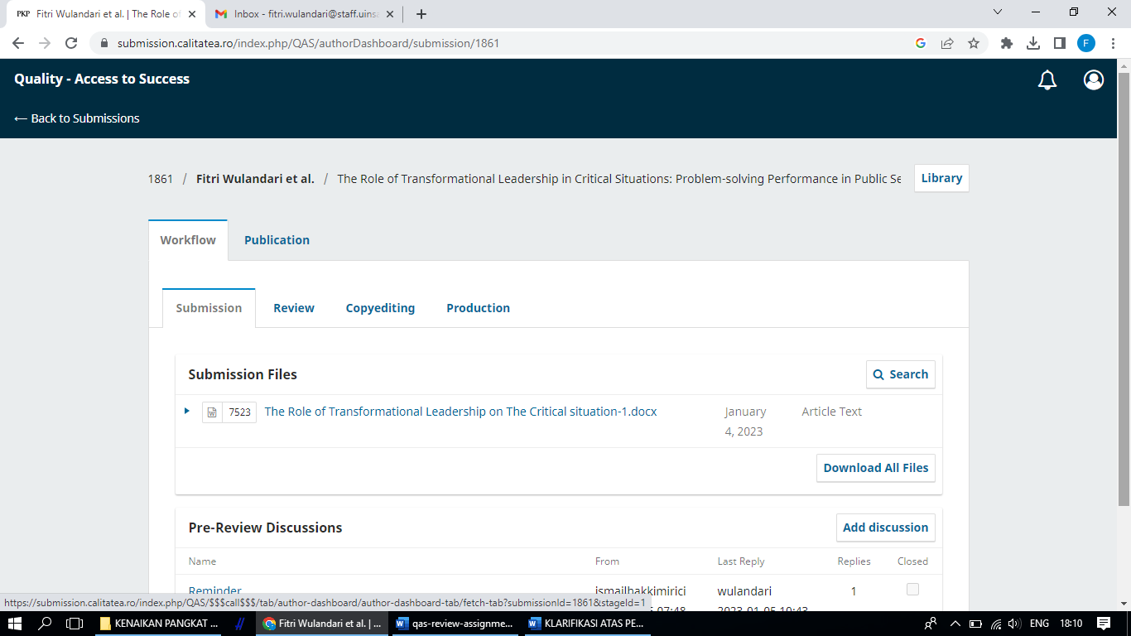

**30 Maret** Our decision is to: Accept Submission



2023-05-27 11:46 AM Catatan Revisi

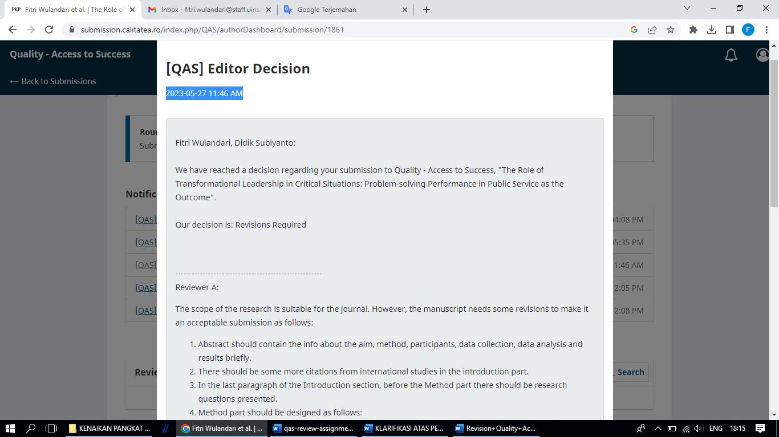

Fitri Wulandari, Didik Subiyanto:  
  
We have reached a decision regarding your submission to Quality - Access to Success, "The Role of Transformational Leadership in Critical Situations: Problem-solving Performance in Public Service as the Outcome".  
  
Our decision is: Revisions Required

------------------------------------------------------  
Reviewer A:

The scope of the research is suitable for the journal. However, the manuscript needs some revisions to make it an acceptable submission as follows:

1. Abstract should contain the info about the aim, method, participants, data collection, data analysis and results briefly.
2. There should be some more citations from international studies in the introduction part.
3. In the last paragraph of the Introduction section, before the Method part there should be research questions presented.
4. Method part should be designed as follows:
5. Method

2.1. Research design

2.2. Participants

2.3. Data collection tools

2.4. Data analysis

1. Results part should be revised, and presented connecting the research questions with more explanations.
2. Discussion part should be created with findings and cited works in the Introduction part.
3. Conclusion should be expanded.
4. References should be revised in accordance with the APA format adding up some more international references used in the text body.

Recommendation: Revisions Required  
  
------------------------------------------------------  
  
  
  
------------------------------------------------------  
Reviewer B:

Structure of the text body needs revision.

Recommendation: Revisions Required

30 Mei 2023 Mengirim revisi



**REVISIONS: QUALITY ACCSESS TO SUCCESS**

|  |  |  |
| --- | --- | --- |
| **Revisions** | **Before** | **After** |
| Abstract should contain the info about the aim, method, participants, data collection, data analysis and results briefly. | **Abstract:** Designing a superior organization requires a leadership style that is strong but adaptable. This study scrutinized the role of transformational leadership in critical situations on problem-solving performance through the moderation of psychological well-being and the mediation of emotional engagement. The sample was randomly selected. They consisted of 258 public service employees in Central Java and the Special Region of Yogyakarta. The data were analyzed using the Structural Equation Model (SEM) with IBM SPSS AMOS 22. This study proved that transformational leadership has a direct effect on problem-solving performance. However, there is no direct effect of transformational leadership on emotional engagement. The results show that psychological well-being moderates the effect of transformational leadership on emotional engagement as well as problem-solving performance. The direct effect of psychological well-being on emotional engagement and problem-solving performance showed significant positive results. In contrast, emotional engagement cannot mediate the effect of transformational leadership on problem-solving performance. Practical implications of this study suggest that employees with a high level of psychological well-being led by transformational leadership styles that guide, inspire and foster a sense of pride in the organization, will encourage high attachment to work indicated by responsibility, perseverance, and enthusiasm that indirectly impact on problem-solving performance in critical situations. Increasing psychological well-being and emotional engagement play the greatest impact in encouraging problem-solving performance. The results indicate that nurturing transformational leadership alone is insufficient to improve problem-solving performance in critical situations, so it takes the moderation of psychological well-being, as well as the mediation of emotional engagement.  **Keywords**: Psychological well-being, transformational leadership, emotional engagement, Problem-solving Performance. | **Abstract:** This study examines the role of transformational leadership (TL) in critical situations with problem-solving performance (PSP) as the dependent variable. A sample of 258 respondents was randomly selected from public service employees in Central Java and Yogyakarta. Data were analyzed using Structural Equation Model (SEM). The results prove that transformational leadership has a direct effect on problem-solving performance, but does not directly affect emotional engagement (EE). The results of this study also indicate that psychological well-being (PWB) moderates the effect of transformational leadership on emotional engagement and problem-solving performance. The direct effect of psychological well-being on emotional engagement and problem-solving performance showed significant positive results. The findings also prove that emotional involvement cannot mediate the effect of transformational leadership on problem-solving performance. The practical implications of this research provide clear directions for the role of transformational leadership, emotional engagement, and psychological well-being in improving employee problem-solving performance in critical situations.  **Keywords**: Psychological well-being, transformational leadership, emotional engagement, Problem-solving Performance |
| There should be some more citations from international studies in the introduction part.  In the last paragraph of the Introduction section, before the Method part there should be research questions presented. | Organizations operate in a dynamic environment that changes rapidly and unexpectedly from time to time without warning. The outbreak caused by Covid-19 in early 2020 in Indonesia compelled organizations to make immediate adjustments to meet the performance goals that had been set. Public/government organizations have a significant commitment to offering community services, including public services, education, and health, hence community services must be prioritized even in times of crisis. The smooth running of the organization is sometimes disrupted during unusual periods, which, of course, has a significant impact on organizational performance. Therefore, quality management is required because it is a determining factor for the success of public services.  To prepare for complex situations, that are unclear when the situations will come to an end, problem-solving skills must be given special attention and implemented immediately (Watkins *et al.*, 2022). The leader of the organization has great responsibility during a crisis. A leader must first create a conducive environment to employee psychology, then motivate, be enthusiastic, and most importantly maintain employee performance. Employees will show better psychological involvement at work when their leaders show transformational leadership (Breevaart *et al.*, 2014). Leaders must still be able to boost employee performance in solving problems in unusual settings during an emergency. Employee engagement is now seen as a strong source of competitive advantage during a crisis (Bedarkar and Pandita, 2014). Complex and complicated problems require qualified human resources. An employee must be able to solve problems quickly and correctly, both those that emerge within and outside the organization.  Robertson & Cooper (2010) introduced the concept of “full engagement”, by proposing that engagement is more likely to be sustainable when employee well-being is also high. Research by Tinline and Crowe (2010) explains that employee involvement is indicated by the workplace connectedness of employees to work extra to increase in order to develop their ability to control the work environment and take advantage of opportunities, in addition to a positive attitude to improve their mental and spiritual health. Transformational leaders encourage cognitive, affective, and behavioral work involvement for organizational success (Park *et al.*, 2021). Several previous studies explored the role of transformational leadership and its influence on employee performance (Subiyanto & Djastuti, 2018; Buil et al., 2019; Carter et al., 2013), and its influence on emotional engagement (Breevaart et al., 2014). Previous studies are empirical evidence of the significance of the role of transformational leadership in an organization in addition to transformational leadership, which has proven to be big and profitable for organizations, psychological well-being brings valuable contributions to organizations, such as its function in improving performance.  Solving emergency problems requires more than knowledge and skills; there must also be a will and spirit from within to be involved in dealing with emergency problems. Thus, it is necessary to develop a comprehensive approach to build the psychology of employees with a strong attachment to their workplace, one of which is with adequate psychological well-being. The constructs of psychological well-being are often complex and multidimensional (Carmeli, Yitzhak-Halevy, and Weisberg, 2009); Nimmi et al., 2021); Şahin and Çankir, 2018); Ryan and Deci, 2001). In its simplest form, psychological well-being often represents happiness (Ryan and Deci, 2001). A person with high life satisfaction typically interprets life with a sense of “gratitude”, and appreciating everything that he has and feeling happy that his life is better than others (Nimmi *et al.*, 2021). There is a void from previous studies in that psychological well-being is more appropriately played as a moderating variable, as it is an individual’s innate nature. Considering that, the role of psychological well-being as a moderator for transformational leadership in increasing emotional engagement and problem-solving performance becomes the focus of this study. This study also investigates the role of emotional engagement in mediating transformational leadership in improving problem-solving performance. | Organizations are in a dynamic environment. The organizational environment changes from time to time, both predictably and unpredictably. Changes in the organizational environment can provide both advantages and disadvantages to the organization. Therefore, organizations must anticipate if there are changes that can be detrimental, by equipping human resources with quality problem-solving skills. problem-solving creativity is an interesting study, it is evident that many studies have been conducted with this theme (Carmeli *et al.*, 2014; Hardy *et al.*, 2017; Hooijdonk *et al.*, 2020; Oppenheimer *et al.*, 2022) In addition, elements of the problem-solving creativity assessment procedure have the potential to require improvement (Hooijdonk *et al.*, 2020).  The Covid-19 outbreak in early 2020 in Indonesia caused a critical situation. Many human activities are paralyzed, due to limited human interaction in all activities. Organizations are required to immediately make strategic adjustments. When the situation is critical, public/government organizations must maintain their commitment to providing quality public services. Therefore, strategic collaboration needs to be engineered in such a way that the activities.  Organizational leaders have great responsibility during critical situations. In complex situations, and it is not clear when the situation will end, the leader must be a driving force in improving problem-solving skills for his subordinates when facing problems in their duties (Bijl *et al.*, 2019). A leader must first create a conducive environment for employee psychology, then motivate, inspire, and most importantly maintain employee performance. Employees will show better psychological involvement at work when their leaders show transformational leadership (Bedarkar and Pandita, 2014). Leaders must still be able to boost employee performance in solving problems in unusual settings during an emergency.  Employee engagement is now seen as a strong source of competitive advantage during a crisis (Bedarkar and Pandita, 2014). Various and complicated problems require qualified human resources. An employee must be able to solve problems quickly and accurately, whether they arise inside or outside the organization even in critical situations.  Robertson & Cooper (2010) introduced the concept of “full engagement”, by proposing that engagement is more likely to be sustainable when employee well-being is also high. Research by Tinline and Crowe (2010) explains that employee involvement is indicated by the workplace connectedness of employees to work extra to increase to develop their ability to control the work environment and take advantage of opportunities and a positive attitude improve their mental and spiritual health.  Transformational leaders encourage cognitive, affective, and behavioral work involvement for organizational success success (Park *et al.*, 2021). Several previous studies explored the role of transformational leadership and its influence on employee performance (Subiyanto & Djastuti, 2018; Buil et al., 2019; Carter et al., 2013), and its influence on emotional engagement (Breevaart *et al.*, 2014; Martinez *et al.*, 2020). Previous studies are empirical evidence of the significance of the role of transformational leadership in an organization in addition to transformational leadership (Alamri, 2023), which has proven to be big and profitable for organizations, psychological well-being brings valuable contributions to organizations (Kim and Cruz, 2022), such as its function in improving performance.  Solving emergency problems requires more than knowledge and skills; there must also be a will and spirit from within to be involved in dealing with emergency problems. Thus, it is necessary to develop a comprehensive approach to build the psychology of employees with a strong attachment to their workplace, one of which is with adequate psychological well-being. Psychological well-being constructs are often complex and multidimensional (Carmeli *et al.*, 2009; Nimmi *et al.*, 2021; Ryan and Deci, 2001; Şahin and Çankir, 2018). In its simplest form, psychological well-being often represents happiness (Ryan and Deci, 2001). A person with high life satisfaction typically interprets life with a sense of “gratitude” appreciating everything that he has and feeling happy that his life is better than others (Nimmi *et al.*, 2021). Previous studies have a void in that psychological well-being is more appropriately played as a moderating variable, as it is an individual’s innate nature. Considering that, the role of psychological well-being as a moderator for transformational leadership in increasing emotional engagement and problem-solving performance becomes the focus of this study. This study also investigates the role of emotional engagement in mediating transformational leadership in improving problem-solving performance.  The problem when the Covid-19 outbreak was very difficult for life in Indonesia. Problem solving ability is the key to success in these conditions. Therefore, this study proposes the formulation of the problem that we develop in the form of research questions; do transformational leadership, emotional engagement, and Psychological Well Being play a positive role on problem solving performance in critical conditions? Based on these research questions, the purpose of this research is to investigate the effect of transformational leadership, emotional engagement as a predictor, and Psychological Well Being as a predictor as well as a moderation on problem solving performance in critical conditions. Psychological Well Being on the other hand as moderation, because researchers have the belief, with the support of logical thinking, that there are individual innate personality factors that are independent. |
| In the last paragraph of the Introduction section, before the Method part there should be research questions presented. |  | The problem when the Covid-19 outbreak was very difficult for life in Indonesia. Problem solving ability is the key to success in these conditions. Therefore, this study proposes the formulation of the problem that we develop in the form of research questions; do transformational leadership, emotional engagement, and Psychological Well Being play a positive role on problem solving performance in critical conditions? Based on these research questions, the purpose of this research is to investigate the effect of transformational leadership, emotional engagement as a predictor, and Psychological Well Being as a predictor as well as a moderation on problem solving performance in critical conditions. Psychological Well Being on the other hand as moderation, because researchers have the belief, with the support of logical thinking, that there are individual innate personality factors that are independent |
| **Method part should be designed as follows:** | | |
| Research design, Participants, Data collection tools, Data analysis |  | **3. Method**  **3.1. Population, Sample, and procedures**  This research is a quantitative study, examining the causal relationship between exogenous and endogenous variables, and involving moderating variables. The population in this study were all employees in the public sector in the Special Region of Yogyakarta and Central Java. Questionnaires were distributed directly to community service office employees, such as PLN, TNI, Polri, hospital nurses/doctors, PDAM, and firefighters. A total of 258 data were obtained through the non-probability sampling method with a purposive sampling technique. Data is processed with AMOS software with Structural Equation Modeling (SEM) analysis tool. |
| References |  | **References**  [1] A. Carmeli, Z. Sheaffer, G. Binyamin, R. Reiter-Palmon, and T. Shimoni, “Transformational leadership and creative problem-solving: The mediating role of psychological safety and reflexivity,” *J. Creat. Behav.*, 2014, doi: 10.1002/jocb.43.  [2] J. H. Hardy, A. M. Ness, and J. Mecca, “Outside the box: Epistemic curiosity as a predictor of creative problem solving and creative performance,” *Pers. Individ. Dif.*, vol. 104, pp. 230–237, 2017, doi: 10.1016/j.paid.2016.08.004.  [3] M. van Hooijdonk, T. Mainhard, E. H. Kroesbergen, and J. van Tartwijk, “Creative Problem Solving in Primary Education: Exploring the Role of Fact Finding, Problem Finding, and Solution Finding across Tasks,” *Think. Ski. Creat.*, vol. 37, no. April, p. 100665, 2020, doi: 10.1016/j.tsc.2020.100665.  [4] A. V Oppenheimer, D. C. Bellinger, B. A. Coull, M. G. Weisskopf, and S. A. Korrick, “The association of prenatal manganese exposure with problem-solving skills and its mediation by the building blocks of executive function,” *Neurotoxicology*, vol. 92, pp. 191–199, 2022, doi: https://doi.org/10.1016/j.neuro.2022.08.009.  [5] A. Bijl, K. Ahaus, G. Ruël, P. Gemmel, and B. Meijboom, “Role of lean leadership in the lean solving relationship: a mixed methods study,” *Heal. Serv. Res. Res.*, vol. 9, no. 6, p. e026737, 2019, doi: 10.1136/bmjopen-2018-026737.  [6] M. Bedarkar and D. Pandita, “A Study on the Drivers of Employee Engagement Impacting Employee Performance,” *Procedia - Soc. Behav. Sci.*, 2014, doi: 10.1016/j.sbspro.2014.04.174.  [7] I. T. Robertson and C. L. Cooper, “Full engagement: The integration of employee engagement and psychological well-being,” *Leadersh. Organ. Dev. J.*, 2010, doi: 10.1108/01437731011043348.  [8] G. Tinline and K. Crowe, “Improving employee engagement and wellbeing in an NHS trust,” *Strateg. HR Rev.*, 2010, doi: 10.1108/14754391011022226.  [9] J. Park, J. Kim, and W. Kim, “Structural relationships among transformational leadership , a ff ective organizational commitment , and job performance : the mediating role of employee engagement,” *Eur. J. Train. Dev.*, 2021, doi: 10.1108/EJTD-10-2020-0149.  [10] D. Subiyanto and I. Djastuti, “Transformational leadership, organizational support, and dynamic ambidexterity capabilities in troubleshooting: Strategic efforts to improve lecturer performance empirical evidence from private universities in Central Java province and the Yogyakarta spec,” *Qual. - Access to Success*, vol. 19, no. 162, 2018, [Online]. Available: https://www.mendeley.com/catalogue/870aaa07-d2ef-3858-b042-466ba4782257/?utm_source=desktop&utm_medium=1.19.4&utm_campaign=open_catalog&userDocumentId=%7B64d55223-6b30-4c60-b1e8-60183c6cb5ec%7D  [11] I. Buil, E. Martínez, and J. Matute, “Transformational leadership and employee performance: The role of identification, engagement and proactive personality,” *Int. J. Hosp. Manag.*, 2019, doi: 10.1016/j.ijhm.2018.06.014.  [12] M. Z. Carter, A. A. Armenakis, H. S. Feild, and K. W. Mossholder, “Transformational leadership, relationship quality, and employee performance during continuous incremental organizational change,” *J. Organ. Behav.*, 2013, doi: 10.1002/job.1824.  [13] K. Breevaart, A. Bakker, J. Hetland, E. Demerouti, O. K. Olsen, and R. Espevik, “Daily transactional and transformational leadership and daily employee engagement,” *J. Occup. Organ. Psychol.*, 2014, doi: 10.1111/joop.12041.  [14] I. M. Martinez, M. Salanova, and V. Cruz-ortiz, “Journal of Work and Organizational Psychology Our Boss is a Good Boss ! Cross-level Effects of Transformational Leadership on Work Engagement in Service Jobs,” *J. Work Organ. Psychol.*, vol. 36, pp. 87–94, 2020.  [15] M. Alamri, “Transformational leadership and work engagement in public organizations: promotion focus and public service motivation, how and when the effect occurs,” *Leadersh. Organ. Dev. J.*, vol. 44, no. 1, pp. 137–155, 2023, doi: 10.1108/LODJ-12-2021-0544.  [16] H. Kim and A. B. Cruz, “Transformational Leadership and Psychological Well-Being of Service-Oriented Staff : Hybrid Data Synthesis Technique,” *Int. J. Environ. Res. Public Health*, vol. 19, no. 13, p. 8189, 2022.  [17] A. Carmeli, M. Yitzhak-Halevy, and J. Weisberg, “The relationship between emotional intelligence and psychological wellbeing,” *J. Manag. Psychol.*, vol. 24, no. 1, pp. 66–78, 2009, doi: 10.1108/02683940910922546.  [18] P. M. Nimmi, A. K. Binoy, G. Joseph, and R. Suma, “Significance of developing spirituality among management students: discerning the impact on psychological resources and wellbeing,” *J. Appl. Res. High. Educ.*, 2021, doi: 10.1108/jarhe-10-2020-0372.  [19] S. Şahin and B. Çankir, “Psychological Well-Being and Job Performance: The Mediating Role of Work Engagement,” *Hitit Üniversitesi Sos. Bilim. Enstitüsü Derg.*, vol. 11, no. 3, 2018, doi: 10.17218/hititsosbil.487244.  [20] R. M. Ryan and E. L. Deci, “On happiness and human potentials: A review of research on hedonic and eudaimonic well-being,” *Annu. Rev. Psychol.*, vol. 52, pp. 141–166, 2001, doi: 10.1146/annurev.psych.52.1.141.  [21] J. Stewart, “Instructional and Transformational Leadership: Burns, Bass and Leithwoood,” *J. Educ. Adm.*, 2006.  [22] T. Park and B. Pierce, “Impacts of transformational leadership on turnover intention of child welfare workers,” *Child. Youth Serv. Rev.*, 2020, doi: 10.1016/j.childyouth.2019.104624.  [23] F. Wulandari, A. T. Ferdinand, and C. Dwiatmadja, “Knowledge sharing in a critical moment of work: A driver for success?,” *Int. J. Knowl. Manag.*, 2018, doi: 10.4018/IJKM.2018040106.  [24] D. Pietraszewski, “Intergroup processes: Principles from an evolutionary perspective,” in *Social Psychology: Handbook of Basic Principles*, 2019.  [25] B. M. Bass, “Two Decades of Research and Development in Transformational Leadership,” *Eur. J. Work Organ. Psychol.*, 1999, doi: 10.1080/135943299398410.  [26] C. A. Yue, L. R. Men, and M. A. Ferguson, “Bridging transformational leadership, transparent communication, and employee openness to change: The mediating role of trust,” *Public Relat. Rev.*, vol. 45, no. 3, p. 101779, 2019, doi: 10.1016/j.pubrev.2019.04.012.  [27] K. Nielsen, J. Yarker, R. Randall, and F. Munir, “The mediating effects of team and self-efficacy on the relationship between transformational leadership, and job satisfaction and psychological well-being in healthcare professionals: A cross-sectional questionnaire survey,” *Int. J. Nurs. Stud.*, vol. 46, no. 9, pp. 1236–1244, 2009, doi: 10.1016/j.ijnurstu.2009.03.001.  [28] S. Çalişkan, G. S. Selçuk, and M. Erol, “Effects of the problem solving strategies instruction on the students’ physics problem solving performances and strategy usage,” in *Procedia - Social and Behavioral Sciences*, 2010. doi: 10.1016/j.sbspro.2010.03.315.  [29] M. . Alzoubi, A. Alrowwad, and R. Masa’deh, “Exploring the relationships among tacit knowledge sharing, communities of practice and employees’ abilities: the case of KADDB in Jordan,” *Int. J. Organ. Anal.*, vol. 30, no. 5, pp. 1132-1155., 2022.  [30] S. Zhang and W. Sun, “The antecedents and outcomes of transformational leadership: leader’s self-transcendent value, follower ’s environmental commitment and behavior,” *Leadersh. Organ. Dev. J.*, vol. 42, no. 7, pp. 1037–1052, 2021, doi: 10.1108/LODJ-10-2020-0471.  [31] A. Carmeli, R. Gelbard, and R. Reiter-Palmon, “Leadership, Creative Problem-Solving Capacity, and Creative Performance: The Importance of Knowledge Sharing,” *Hum. Resour. Manage.*, 2013, doi: 10.1002/hrm.21514.  [32] M. Shafi, Zoya, Z. Lei, X. Song, and M. N. I. Sarker, “The effects of transformational leadership on employee creativity: Moderating role of intrinsic motivation,” *Asia Pacific Manag. Rev.*, 2020, doi: 10.1016/j.apmrv.2019.12.002.  [33] S. K. Singh, M. Del Giudice, R. Chierici, and D. Graziano, “Green innovation and environmental performance: The role of green transformational leadership and green human resource management,” *Technol. Forecast. Soc. Change*, vol. 150, no. September 2019, p. 119762, 2020, doi: 10.1016/j.techfore.2019.119762.  [34] J. A. Folgado-fern, P. Duarte, and J. M. Hern, “Tourist ’ s rational and emotional engagement across events: a multi-event integration view,” *Int. J. Contemp. Hosp. Manag.*, vol. 33, no. 7, pp. 2371–2390, 2021, doi: 10.1108/IJCHM-09-2020-1098.  [35] Ş. Ç. Özhan and S. A. Kocadere, “The Effects of Flow, Emotional Engagement, and Motivation on Success in a Gamified Online Learning Environment,” *J. Educ. Comput. Res.*, vol. 57, no. 8, pp. 2006–2031, 2020, doi: 10.1177/0735633118823159.  [36] J. A. Gruman and A. M. Saks, “Performance management and employee engagement,” *Hum. Resour. Manag. Rev.*, vol. 21, no. 2, pp. 123–136, 2011, doi: 10.1016/j.hrmr.2010.09.004.  [37] W. B. Schaufeli, A. B. Bakker, and M. Salanova, “The measurement of work engagement with a short questionnaire: A cross-national study,” *Educ. Psychol. Meas.*, vol. 66, no. 4, pp. 701–716, 2006, doi: 10.1177/0013164405282471.  [38] P. Swierzy, P. Wicker, and C. Breuer, “The impact of organizational capacity on voluntary engagement in sports clubs : A multi-level analysis,” *Sport Manag. Rev.*, pp. 1–14, 2017, doi: 10.1016/j.smr.2017.08.001.  [39] O. M. Z. Abd-allah, “The Relationship between organizational citizenship behavior and employee engagement in Cement Industry in Egypt,” *Int. J. Manag. Commer. Innov.*, vol. 4, no. 1, pp. 362–376, 2016.  [40] Y. Zhang, Y. Guo, and A. Newman, “Identity judgements , work engagement and organizational citizenship behavior: The mediating effects based on group engagement model,” *Tour. Manag.*, vol. 61, pp. 190–197, 2017, doi: 10.1016/j.tourman.2017.01.005.  [41] M. Kaliannan and S. Narh, “Effective employee engagement and organizational success: a case study,” *Procedia - Soc. Behav. Sci.*, vol. 172, pp. 161–168, 2015, doi: 10.1016/j.sbspro.2015.01.350.  [42] J. Mencl, A. J. Wefald, and K. W. van Ittersum, “Transformational leader attributes: Interpersonal skills, engagement, and well-being,” *Leadersh. Organ. Dev. J.*, vol. 37, no. 5, pp. 635–657, 2016, doi: 10.1108/01437739199500003.  [43] S. Sahu, A. Pathardikar, and A. Kumar, “Transformational leadership and turnover: Mediating effects of employee engagement, employer branding, and psychological attachment,” *Leadersh. Organ. Dev. J.*, vol. 39, no. 1, pp. 82–99, 2018, doi: 10.1108/LODJ-12-2014-0243.  [44] Y. M. Kundi, S. Sardar, and K. Badar, “Linking performance pressure to employee work engagement: the moderating role of emotional stability,” *Pers. Rev.*, vol. ahead-of-p, no. ahead-of-print, 2021, doi: 10.1108/pr-05-2020-0313.  [45] A. J., “Determinants of employee engagement and their impact on employee performance,” *Int. J. Product. Perform. Manag.*, vol. 63, no. 3, pp. 308–323, 2014, doi: 10.1108/IJPPM-01-2013-0008.  [46] A. Stankevičienė, V. Tamaševičius, and D. Diskienė, “The mediating effect of work-life balance on the relationship between work culture and employee well-being,” *J. Bus. Econ. Manag.*, vol. 22, no. 4, pp. 988–1007, 2021.  [47] I. T. Robertson, A. J. Birch, and C. L. Cooper, “Job and work attitudes, engagement and employee performance Where does psychological well-being fit in?,” *Leadersh. Organ. Dev. J.*, vol. 33, no. 3, pp. 224–232, 2012, doi: DOI 10.1108/01437731211216443.  [48] Y. M. Kundi, M. Aboramadan, E. M. I. Elhamalawi, and S. Shahid, “Employee psychological well-being and job performance: exploring mediating and moderating mechanisms,” *Int. J. Organ. Anal.*, vol. 29, no. 3, pp. 736–754, 2020, doi: 10.1108/IJOA-05-2020-2204.  [49] L. K. Jena, S. Pradhan, and N. P. Panigrahy, “Pursuit of organisational trust: Role of employee engagement, psychological well-being and transformational leadership,” *Asia Pacific Manag. Rev.*, vol. 23, no. 3, pp. 227–234, 2018, doi: 10.1016/j.apmrv.2017.11.001.  [50] C. D. Ryff, “Happiness is everything, or is it? Explorations on the meaning of psychological well-being.,” *J. Pers. Soc. Psychol.*, vol. 57, no. 6, pp. 1069–1081, 1989, doi: 10.1037/0022-3514.57.6.1069.  [51] K. A. C. L. M. M. Walsh, “Transformational leadership in an extreme context: examining gender, individual consideration and self- sacrifice,” *Leadersh. Organ. Dev. Journal,* vol. 37, no. 6, 2016.  [52] K. E. Watkins *et al.*, “Accelerating problem-solving capacities of sub-national public health professionals: an evaluation of a digital immunization training intervention,” *BMC Health Serv. Res.*, vol. 22, no. 1, pp. 1–9, 2022, doi: 10.1186/s12913-022-08138-4.  [53] A. P. Mangkunegara, “The Role of Transformational Leadership In Building Work Engagement and Performance of Business Company Managers,” *J. Leg. Ethical Regul. Issues*, vol. 24, no. Special Issue 1, pp. 1–19, 2021.  [54] M. Kim, Y. Do Kim, and H. W. Lee, “It is time to consider athletes’ well-being and performance satisfaction: The roles of authentic leadership and psychological capital,” *Sport Manag. Rev.*, 2020, doi: 10.1016/j.smr.2019.12.008.  [55] M. Mohaghegh and A. Größler, “Exploring organizational problem-solving modes: a dynamic capabilities approach,” *Manag. Decis.*, vol. 60, no. 1, pp. 254–277, 2022, doi: 10.1108/MD-08-2020-1097.  [56] S. C. H. Chan, “Participative leadership and job satisfaction: The mediating role of work engagement and the moderating role of fun experienced at work,” *Leadersh. Organ. Dev. J.*, vol. 40, no. 3, pp. 319–333, 2019, doi: 10.1108/LODJ-06-2018-0215. |

