Korespondensi International Journal Knowledge Management
IJKM: Volume 14, Issue 2, Article 6.
Knowledge Sharing in a Critical Moment of Work; a Driver for Success? (041117-011342)
Login: fitri.wulandari@iain-surakarta.ac.id
Password: wulandari

IGI Global
eEditorial Discovery®
IJKM: Volume 14, Issue 2, Article 6.
Knowledge Sharing in a Critical Moment of Work; a Driver for Success? (041117-011342)
Login: fitri.wulandari@iain-surakarta.ac.id
Password: wulandari

• Published 3/26/2018 - 3/26/2018
• Download Final Materials 3/25/2018 - 3/26/2018
• Final Materials 3/25/2018 - 3/25/2018
• Revision Received 3/24/2018 - 3/24/2018
• Revision Received 3/24/2018 - 3/24/2018
• Revision Received 3/24/2018 - 3/25/2018
• Editor-in-Chief Revision Requested 3/17/2018 - 3/24/2018
• Revision Received 2/15/2018 - 3/17/2018
• Editor-in-Chief Revision Requested 1/25/2018 - 2/15/2018
• Revision Received 1/15/2018 - 1/15/2018
• Revision Received 1/15/2018 - 1/25/2018
• Editor-in-Chief Revision Requested 12/27/2017 - 1/15/2018
• Assess and Approve Editorial Review Board Evaluations 11/4/2017 - 12/27/2017
• Select and Contact Editorial Review Board Evaluators 11/4/2017 - 11/4/2017
• Remove Identifying Information 11/4/2017 - 11/4/2017
• Initial Assessment 7/26/2017 - 11/4/2017
• Submission 7/26/2017 - 7/26/2017

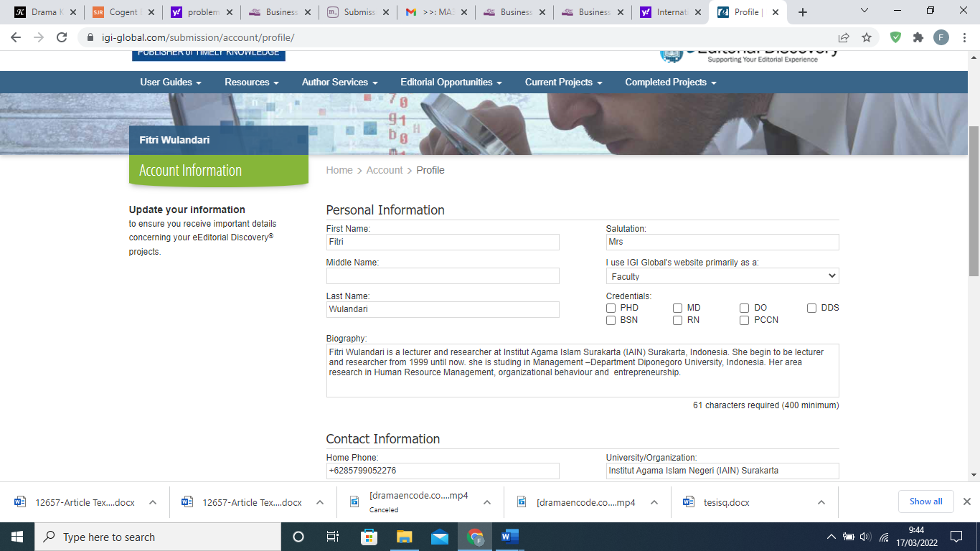

Dear Mrs Wulandari,
You will be happy to know that your manuscript #041117-011342, entitled "Knowledge Sharing in a Critical Moment of Work; a Driver for Success?," submitted to the International Journal of Knowledge Management (IJKM), has passed the journal's editorial review process. Next, your manuscript will be submitted to IGI Global for a final check to ensure that all publication requirements have been met. Your paper cannot be formally accepted for publication until this final step is complete. To ensure the timely and efficient completion of this step, please check that you have completed the following:
• All final submission requirements have been met as outlined in the Author’s Checklist: http://www.igi-global.com/publish/resources/journal-author-checklist.pdf
• Each author on your manuscript has updated and confirmed their biography, email, and mailing address, and has signed the Author’s Warranty and Transfer of Copyright Agreement. Any authors who have yet to complete any of these items may do so here: https://www.igi-global.com/submission/copyright-agreement/?projectid=f5846d42-f142-4423-8400-702ae96f01da
Should any of these items need to be corrected, you will be contacted by a member of IGI Global’s journal development team. They are also able to provide you with the necessary documents and instruction surrounding these items prior to publication.
No manuscript will be accepted unless it strictly follows the manuscript guidelines, i.e., must be professionally copyedited, references and citations formatted according to APA style guidelines, and includes all mandatory sections (Introduction, Conclusion, and References).
Should you have any questions, please feel free to contact me, murray jennex, at murphjen@aol.com.
mjennex@mail.sdsu.edu
E-mail: ijkm@igi-global.com

Dear
Dr. Murray Jennex
Editor-in-Chief
San Diego State University, USA
The final revision of my manuscript #041117-011342, entitled "Knowledge Sharing in a Critical Moment of Work; a Driver for Success? in International Journal Knowledge Management have been sent on 15th February 2018. Since I have problem with my e-mail, fitri.wulandari@iain-surakarta.ac.id, could you please sent any feedback to my another e-mail at nfitri_wulandari@yahoo.com.

Best Wishes
Fitri Wulandari

Dear Mrs Wulandari,
You will be happy to know that your manuscript #041117-011342, entitled "Knowledge Sharing in a Critical Moment of Work; a Driver for Success?," submitted to the International Journal of Knowledge Management (IJKM), has passed the journal's editorial review process. Next, your manuscript will be submitted to IGI Global for a final check to ensure that all publication requirements have been met. Your paper cannot be formally accepted for publication until this final step is complete. To ensure the timely and efficient completion of this step, please check that you have completed the following:
• All final submission requirements have been met as outlined in the Author’s Checklist: http://www.igi-global.com/publish/resources/journal-author-checklist.pdf
• Each author on your manuscript has updated and confirmed their biography, email, and mailing address, and has signed the Author’s Warranty and Transfer of Copyright Agreement. Any authors who have yet to complete any of these items may do so here: https://www.igi-global.com/submission/copyright-agreement/?projectid=f5846d42-f142-4423-8400-702ae96f01da
Should any of these items need to be corrected, you will be contacted by a member of IGI Global’s journal development team. They are also able to provide you with the necessary documents and instruction surrounding these items prior to publication.
No manuscript will be accepted unless it strictly follows the manuscript guidelines, i.e., must be professionally copyedited, references and citations formatted according to APA style guidelines, and includes all mandatory sections (Introduction, Conclusion, and References).
Should you have any questions, please feel free to contact me, murray jennex, at murphjen@aol.com.
IGI Global
eEditorial Discovery®

Dear Mrs Wulandari,
The review of your manuscript #041117-011342, entitled "Knowledge Sharing in a Critical Moment of Work; a Driver for Success?," has been completed. Although we find the topic to be important, we believe the coverage should be strengthened according to the feedback listed below before the manuscript can be accepted for publication in an upcoming issue of the International Journal of Knowledge Management (IJKM).
I am fine with all your revisions with the exception of the KM literature review on teams. There is just too much literature and adding one citation does not meet what is needed. Please review the IJKM literature (https://www.igi-global.com/journal/international-journal-knowledge-management/1083) as well as other KM journals for appropriate literature. Final acceptance is based on doing this well as your paper as is, is not grounded in the KM literature. Thanks...murray
Please address the noted concerns and upload your revised, final manuscript at the following page:
https://www.igi-global.com/submission/submit-manuscript/?projectid=f5846d42-f142-4423-8400-702ae96f01da&s=2
To ensure the timely and efficient completion of this step, please ensure that you have completed the following:
• All requirements and guidelines have been met as outlined in the Before You Write guide: http://www.igi-global.com/publish/contributor-resources/before-you-write/
• All final submission requirements have been met as outlined in the Author’s Checklist: http://www.igi-global.com/publish/resources/journal-author-checklist.pdf
• Each author on your manuscript has updated and confirmed their biography, email, and mailing address, and has signed the Author’s Warranty and Transfer of Copyright Agreement. Any authors who have yet to complete any of these items may do so here: https://www.igi-global.com/submission/copyright-agreement/?projectid=f5846d42-f142-4423-8400-702ae96f01da
For consistency of publication, we ask that you ensure that your paper meets APA style guidelines. Manuscripts should be limited to 20 double-spaced pages (including references). We ask that you kindly adhere to these guidelines. In addition, please carefully go over the "Guidelines for Preparing Accepted Manuscripts":
https://www.igi-global.com/submission/accepted-manuscript-guidelines/
Please ensure that your materials reach us no later than March 24, 2018.
The final decision regarding publication of the manuscript depends on an additional round of reviews. Please be advised that revision does not guarantee acceptance.
If you have any questions, feel free to contact me, murray jennex, at murphjen@aol.com.
IGI Global
eEditorial Discovery®

Point of Review
This manuscript has been changed as your request.
For consistency of publication, we ask that you ensure that your paper meets APA style guidelines. Manuscripts should be limited to 20 double-spaced pages (including references). We ask that you kindly adhere to these guidelines. In addition, please carefully go over the "Guidelines for Preparing Accepted Manuscripts":
Review from Editor

1. The sentences in Table 1 don't read very well. Is this because they are translated from Indonesian?
Before
Table 1. Scale Item for Measures
Reflective scale names items (measured on 10-point scale indicating the extent to which respondent agrees with following statements) | Standardized loading factor
Knowledge sharing in a critical moment (Cronbach’s α =0.855)  - I always tried to divide information about the important tasks  - I always sharing a new ideas to problem solutiob about the job and uncertainly.  - I always sharing ideas on problem solving the key work to be accomplished  - I always share experiences in his new job | 0.790  0.620  0.790  0.910
Affective commitment (Cronbach’s α =0.909)  - I Have interaction ties with organization  - Capability to explore a potential competence to achieving organizational vision  - Not easily gave for realize the purpose company  - Implement that values it can be achieved.( as oriented on the consumer, attitude responsible, professional in employment ) | 0.750  0.900  0.860  0.870
Group awareness on organizational objective (Cronbach’s α =0.880)  - Having an orientation a specific purpose  - Always participate achieve objectives challenge  trying to realize the purpose of being difficult to achieve  - I have concern high to the purpose organization | 0.710  0.830  0.820  0.800
Career success (Cronbach’s α =0.890)  - I have success financially  - I have a high position of office  - The promotion of my position the faster than my estimation  - I have career satisfaction | 0.750  0.890  0.820  0.810
Teamwork quality (Cronbach’s α =0.826)  - The team work is very dynamic so easy to encourage the change  - The team work always mutual partnership to help an each other to achieve the target of organization.  - My team always responsiveness.  - The members of team work always complimenting ideas to be implemented | 0.600  0.870  0.750  0.870

AFTER
Table 1. Scale Item for Measures
Reflective scale items | Standardized loading factor | Cronbach’s α | Composite Reliability | AVE
Knowledge sharing in a critical moment  - Sharing information on important tasks  - Sharing new ideas to solve confusing and uncertain tasks  - Sharing ideas to meet the target finish date  - Sharing experiences to synergize on a new task | 0.790  0.620  0.790  0.910 | 0,855 | 0,863 | 0,615
Affective commitment  - Having a strong feeling of attachment with the company  - Putting all efforts and maximizing potentials to realize the company’s vision  - Striving to achieve the goals  - Implementing the company values | 0.750  0.900  0.860  0.870 | 0,909 | 0,910 | 0,717
Group awareness on organizational objective  - Having a specific goal orientation  - Getting involved or participating in achieving a challenging goal  - Striving to realize difficult and complex goals  - Being responsible to achieve the goals of the organization | 0.710  0.830  0.820  0.800 | 0,880 | 0,870 | 0,626
Career success  - Having financial success  - Having a high position in the office  - Getting promotions faster  - Having a high career satisfaction | 0.750  0.890  0.820  0.810 | 0,890 | 0,891 | 0,671
Teamwork quality  - Dynamic teamwork that can face drastic change on a task  - Solid teamwork that can work together to finish a task  - Responsive teamwork when needed  - Supportive teamwork on new ideas | 0.600  0.870  0.750  0.870 | 0,826 | 0,860 | 0,610

II. Not sure if it's due to the incompatibility of file formats, the relationship between variables in Table 2 is not presented in a proper way and a bit hard to read. And it would be easier to read if the results are marked with their corresponding hypotheses and presented in the same order as hypotheses.
Before
Table 2. Summary of Results from the SEM Models
Relationship | Path Coeff. | CR | Prob. | Hypotheses
Knowledge sharing in critical moment →career Success | 0.562 | 2.395 | 0.017 | Supported
Affective Commitment →knowledge sharing in critical moment | 0.417 | 2.862 | 0.004 | Supported
Group Awareness on Organizational Objective→knowledge sharing in critical moment | 0.577 | 5,132 | 0.000 | Supported
Group Awareness on Organizational Objective→Affective Commitment | 0.464 | 5.537 | 0.000 | Supported
Knowledge sharing in critical moment→Quality Teamwork | 0.937 | 8.795 | 0.000 | Supported
Quality Teamwork→ career success | 0,049 | 0,238 | 0,812 | Not  Supported

Table 2 explains that Knowledge sharing in critical moment significantly influences career success at (β=0.562, CR= 2.395, p<0.05). Thus, hypothesis 1 is confirmed. Affective Commitment influences knowledge sharing in critical moment at (β=0.417, CR= 2.862, p<0.01). Hence, hypothesis 2 is confirmed. The results show that Group Awareness on Organizational Objective influences knowledge sharing in critical moment (β=0.577, CR= 0.5132, p<0.01), meaning that hypothesis 3 is confirmed. Group Awareness on Organizational Objective influences Affective Commitment (β=0.464, CR= 0.5537, p<0.01), meaning that hypothesis 4 is confirmed. Knowledge sharing in critical moment has significant influence onteamwork quality (β=0.937, CR= 0.8795, p<0.01), meaning that hypothesis 5 is confirmed. And teamwork quality has no significant influence on career success (β=0.049, CR= 0.238, p>0.05), meaning that hypothesis 6 is not supported. These results indicate that the five hypotheses built in this research are supported and only one hypothesisis insignificant.

After
Table 2. Summary of Results from the SEM Models

Hypothesis | Relationship | Path Coeff. | CR | Prob. | Hypotheses
H1 | Knowledge sharing in critical moment →career Success | 0.562 | 2.395 | 0.017 | Supported
H2 | Affective Commitment →knowledge sharing in critical moment | 0.417 | 2.862 | 0.004 | Supported
H3 | Group Awareness on Organizational Objective→knowledge sharing in critical moment | 0.577 | 5,132 | 0.000 | Supported
H4 | Group Awareness on Organizational Objective→Affective Commitment | 0.464 | 5.537 | 0.000 | Supported
H5 | Knowledge sharing in critical moment→Quality Teamwork | 0.937 | 8.795 | 0.000 | Supported
H6 | Quality Teamwork→ career success | 0,049 | 0,238 | 0,812 | Not  Supported

Table 2 explains that Knowledge sharing in critical moment significantly influences career success at (β=0.562, CR= 2.395, p<0.05) meaning that hypothesis 1 is confirmed. Thus, hypothesis 2 is confirmed. Affective Commitment influences knowledge sharing in critical moment at (β=0.417, CR= 2.862, p<0.01). Hence, hypothesis 2 is confirmed. The results show that Group Awareness on Organizational Objective influences knowledge sharing in critical moment (β=0.577, CR= 0.5132, p<0.01), meaning that hypothesis 3 is confirmed. Group Awareness on Organizational Objective influences Affective Commitment (β=0.464, CR= 0.5537, p<0.01), meaning that hypothesis 4 is confirmed. Knowledge sharing in critical moment has significant influence quality teamwork (β=0.937, CR= 0.8795, p<0.01), meaning that hypothesis 5 is confirmed. And teamwork quality has no significant influence on career success (β=0.049, CR= 0.238, p>0.05), meaning that hypothesis 6 is not supported. These results indicate that the five hypotheseses built in this research are supported and only one hypothesis is not significant.

III. The term SEM is first presented without proper explanation ("The hypothesis testing in this research uses SEM approach") in the "Data Analysis and Measurement Models" section, which may confuse readers who are not familiar with it. Its full name is only presented (twice) in the "Results" section. It would also be better if a bit more background knowledge is introduced for this SEM approach.

Before
Data Analysis and Measurement Models
The hypothesis testing in this research uses SEM approach. The testing using SEM includes two types of variables, namely observable/manifest variable and latent/non-observable variables. In evaluating the fit of the model, several goodness-of-fit indices use normed fit index (NFI); comparative fit index (CFI); Tucker-Lewis index (TLI); root mean square error of approximation (RMSEA) in addition to the X² statistics.

After
Data Analysis and Measurement Models
The hypothesis testing in this research uses SEM approach. The testing using SEM includes two types of variables, namely observable/manifest variable and latent/non-observable variables. SEM (Structural Equation Modeling) consists of two main parts which are measurement model to confirm the indicators of the latent variables and structural model which can represent the causality of two or more variables. Structural model is a model of relationship structure which shapes or explains the causality between the factors (Ferdinand, 2014).
In evaluating the fit of the model, several goodness-of-fit indices use normed fit index (NFI); comparative fit index (CFI); Tucker-Lewis index (TLI); root mean square error of approximation (RMSEA) in addition to the X² statistics. We further evaluate the measurement properties by performing a confirmatory factor analysis. Each item is set to load only on its respective latent construct, and the latent constructs are allowed to be correlated. The results indicate that the measurement models have loading factor greater than 0.6. The research concludes that these indicators can explain for measuring construct. However, one element in the knowledge sharing in critical moment construct has loading factor score less than 0.6 yet the analysis still proceed to the next one since it is viewed as fine due to the fact that it is greater than 0.4 (Guest et al., 2014).

IV. The abstract of this paper can also be improved to better summarize the main content and contributions with a clearer logic and more specific points, which will interest more audiences to read.
Before
ABSTRACT
This research aims at proving empirically the influence of social interaction in knowledge sharing with its focus on key persons and the way the knowledge-sharing is spread in order to produce some outcome for the organization through individuals within it. Knowledge sharing in critical moment is expected to improve employees’ career success. The object in this study is employees of Post Offices in Central Java who frequently share information with their co-workers in accomplishing their jobs. The analysis units in this research are supervisors and managers. It uses 210 questionnaires as its data, which are obtained using purposive sampling method. The results indicate that the five hypotheses built in this research are supported and only one hypothesis is not supported.
KEYWORD: Affective Commitment, knowledge sharing, critical moment, goal
setting, Teamwork Quality, career success.

After
This research aims at proofing empirically the influence of social interaction in knowledge sharing by focusing on key persons and the way the knowledge-sharing is spread in order to produce some outcome for the organization through individuals within it. Knowledge sharing in critical moment is expected to improve employees’ career success. The object of this study is employees of Post Offices in Central Java who frequently share information with their co-workers in accomplishing their jobs. The analysis units in this research are supervisors and managers. The data is acquired from questionnaires distributed to managers and supervisor level of Post office. Based on purposive sampling method, 210 samples are obtained. The results indicate that the five hypotheseses built in this research are supported and only one hypothesis is not supported. The result shows that employees with specific, complicated, and challenging objective will be more willing to share their knowledge to other employees, particularly when facing new job and target. Furthermore, the result of the study explain that sharing idea of improvement will encourage more dynamic teamwork and help each other in completing any problem.

KEYWORD: Affective Commitment, Knowledge Sharing, Critical Moment, Goal
Setting, Teamwork Quality, Career Success.

All this must be improved and the paper must tell a story that can be understood by the readers. I also suggest having the paper professionally proof read for grammar.
This article has been proofread by professional proofreader.

I see you have addressed reviewer 2's comments but I don't think you understood reviewer 1's comment, as I have the same impression of the paper let me elaborate:
What is the paper about? I've gone over it a couple of times and get a different impression each time, is it about career satisfaction, group and/or team knowledge sharing, or something to do with critical moment? I can't tell and the paper talks about all 3. This must be clarified.

Before
This study aims to enrich the previous work by investigating empirically the influence of self awareness on organizational objective on affective commitment and its support in driving knowledge-sharing behavior from manager/supervisor. Someone with strong commitment has a tendency to do various works which conform the organization goals (Odunayo, Arogundade Ayodeji, & M, 2014). Knowledge sharing is needed by organizations in introducing intergroup works by encouraging employees to share their knowledge and expertise to each other to deal with complicated tasks at work. Knowledge sharing in critical moment is a way to nurture knowledge sharing for solving numerous important problems within the organization. Building knowledge sharing in critical moment is expected to improve teamwork quality even further and eventually it will improve career success.

After
This study aims to enrich the previous researches by investigating empirically the influence of self awareness on organizational objective on affective commitment and its support in driving knowledge-sharing behavior from manager/supervisor. Individuals tend to have certain standards and strive to achieve these standards using various actions directed towards what they are longing for. This explains why people have strong motivation to succeed; those with specific and hard-to-achieve goals will be more successful than those with unclear or easily-attainable goals (Polson, 2013). Someone with strong commitment has a tendency to do various works which conform the organization goals (Odunayo, Arogundade Ayodeji, & M, 2014). Knowledge sharing is needed by organizations in introducing intergroup works by encouraging employees to share their knowledge and expertise to each other to deal with complicated tasks at work. Knowledge sharing in critical moment is a way to nurture knowledge sharing for solving numerous important problems within the organization. Building knowledge sharing in critical moment is expected to improve teamwork quality even further and eventually it will improve career success.

In all cases above the literature review is inadequate, contrary to what I think you believe this is not a new topic, there is lots of KM research on teams, knowledge sharing, performance, etc. You must use the KM literature.
Knowledge management is a simplification and improvement of the process of knowledge creation, knowledge sharing, knowledge distribution, and obtaining knowledge in an organization (Torabi, Kyani & Falakinia, 2016). The core of knowledge management is an approach which shows how the knowledge in an organization can be generated and utilized by the members of the organization to encourage competitiveness. Knowledge management as the main aspect of competitiveness can be realized through creativity, innovation, productivity and reputation which gradually increase the organization’s revenue. Knowledge sharing, therefore, is essential to support the successful knowledge management. Knowledge sharing is an important dimention in knowledge management. Initial studies in different fields of science is basically an action which causes knowledge to exist and be available for other people in an organization and individuals are the key persons in the process of knowledge sharing (Wang & Noe, 2010).

Point of Review: 24/03/ 2018
Before
Knowledge management is a simplification and improvement of the process of knowledge creation, knowledge sharing, knowledge distribution, and obtaining knowledge in an organization (Torabi, Kyani & Falakinia, 2016). The core of knowledge management is an approach which shows how the knowledge in an organization can be generated and utilized by the members of the organization to encourage competitiveness. Knowledge management as the main aspect of competitiveness can be realized through creativity, innovation, productivity and reputation which gradually increase the organization’s revenue. Knowledge sharing, therefore, is essential to support the successful knowledge management. Knowledge sharing is an important dimention in knowledge management. Initial studies in different fields of science is basically an action which causes knowledge to exist and be available for other people in an organization and individuals are the key persons in the process of knowledge sharing (Wang & Noe, 2010).

After
Lending the notion of knowledge management, we introduce the concept of knowledge sharing in the critical moment (KSCM) as a mediation of group awareness on organizational objectives to career success. Knowledge management is the key in increasing competitiveness through creativity, innovation, productivity and reputation which ultimately increases organizational benefits. The essence of knowledge management is an approach on how knowledge in an organization can be generated and utilized by its members to push competitiveness (Ganguly, Mostashari, & Mansouri, 2011). Knowledge sharing is an important dimension of knowledge management. An effective management strategy will affect the process of sharing appropriate knowledge to the organization, especially how the organization is able to motivate employees to continue to share knowledge with fellow employees in order to improve innovation and teamwork (Carvalho, 2017). In an organization, sharing knowledge among its members is useful for solving complex problems such as problems that come repeatedly and constantly which require immediate improvement, where problem solving is the process of removing barriers to finding solutions (Hou et al., 2014).

Before
In order to reach this difficult target, one should set challenging, specific, measurable goals, attainable, relevant and timely goals (Latham, 2003). In setting goals, it is therefore necessary to set the goals that one wants from the beginning. The desired goals should be the superordinate ones. In Sholihin, Pike, Mangena, & Li (2011) research, it is found that participation in goals drives individuals to increase their commitment even greater towards those goals. The knowledge owned by individuals is not necessarily something easily accessible. Under some circumstances, one prefers storing up knowledge until a certain motivation factor occurs to influence his/her intention to share his/her knowledge. Various studies explain that the important factors which influence the successful knowledge sharing process in an organization are highly determined by the strong motivation of individuals within the organization for sharing (Allameh, Abedini, Pool, & Kazemi, 2012; Locke et al., 2006).
After
In order to reach this difficult target, one should set challenging, specific, measurable goals, attainable, relevant and timely goals (Latham, 2003). In setting goals, it is therefore necessary to set the goals that one wants from the beginning. The desired goals should be the superordinate ones. In Sholihin, Pike, Mangena, & Li (2011) research, it is found that participation in goals drives individuals to increase their commitment even greater towards those goals. The knowledge owned by individuals is not necessarily something easily accessible. Under some circumstances, one prefers storing up knowledge until a certain motivation factor occurs to influence his/her intention to share his/her knowledge. Various studies explain that the important factors which influence the successful knowledge sharing process in an organization are highly determined by the strong motivation of individuals within the organization for sharing (Allameh, Abedini, Pool, & Kazemi, 2012; Twum-Darko & Harker, 2017).

Before
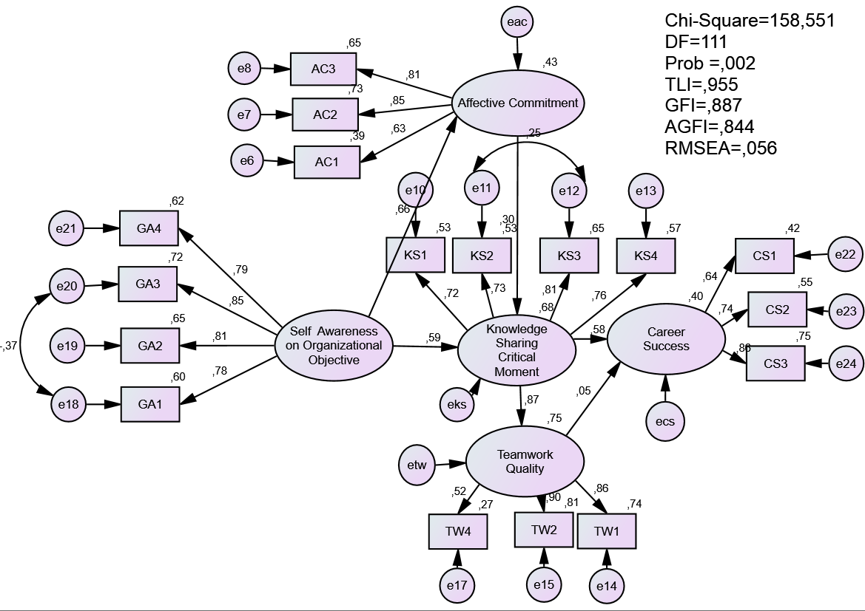

After

