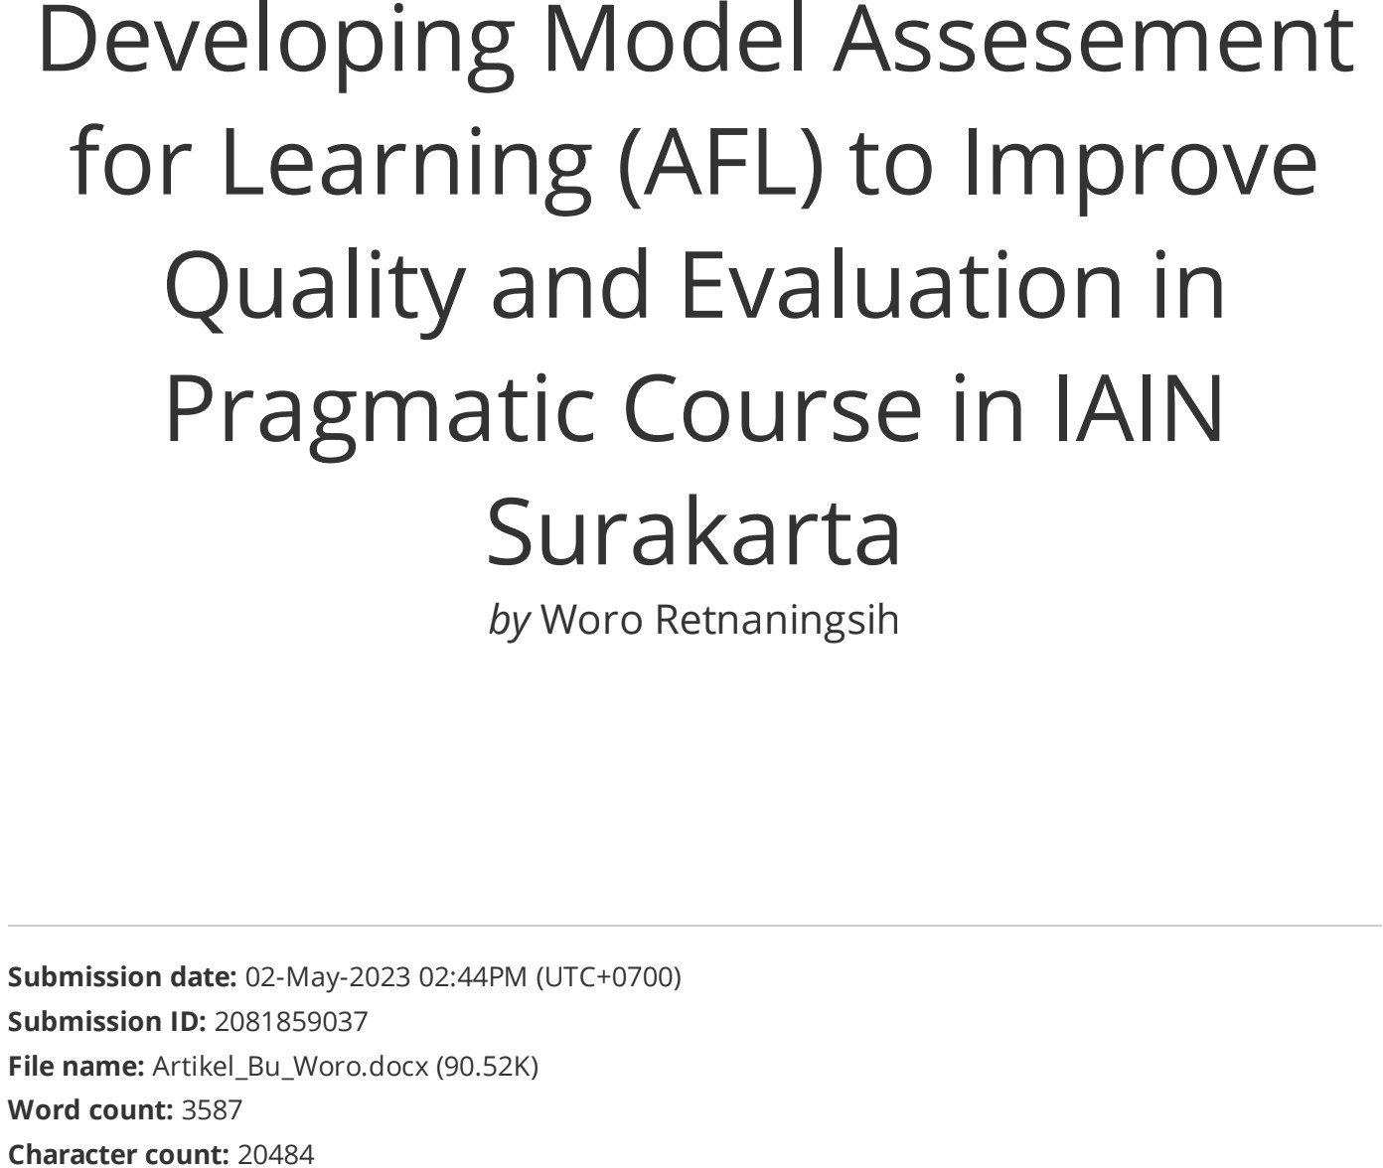

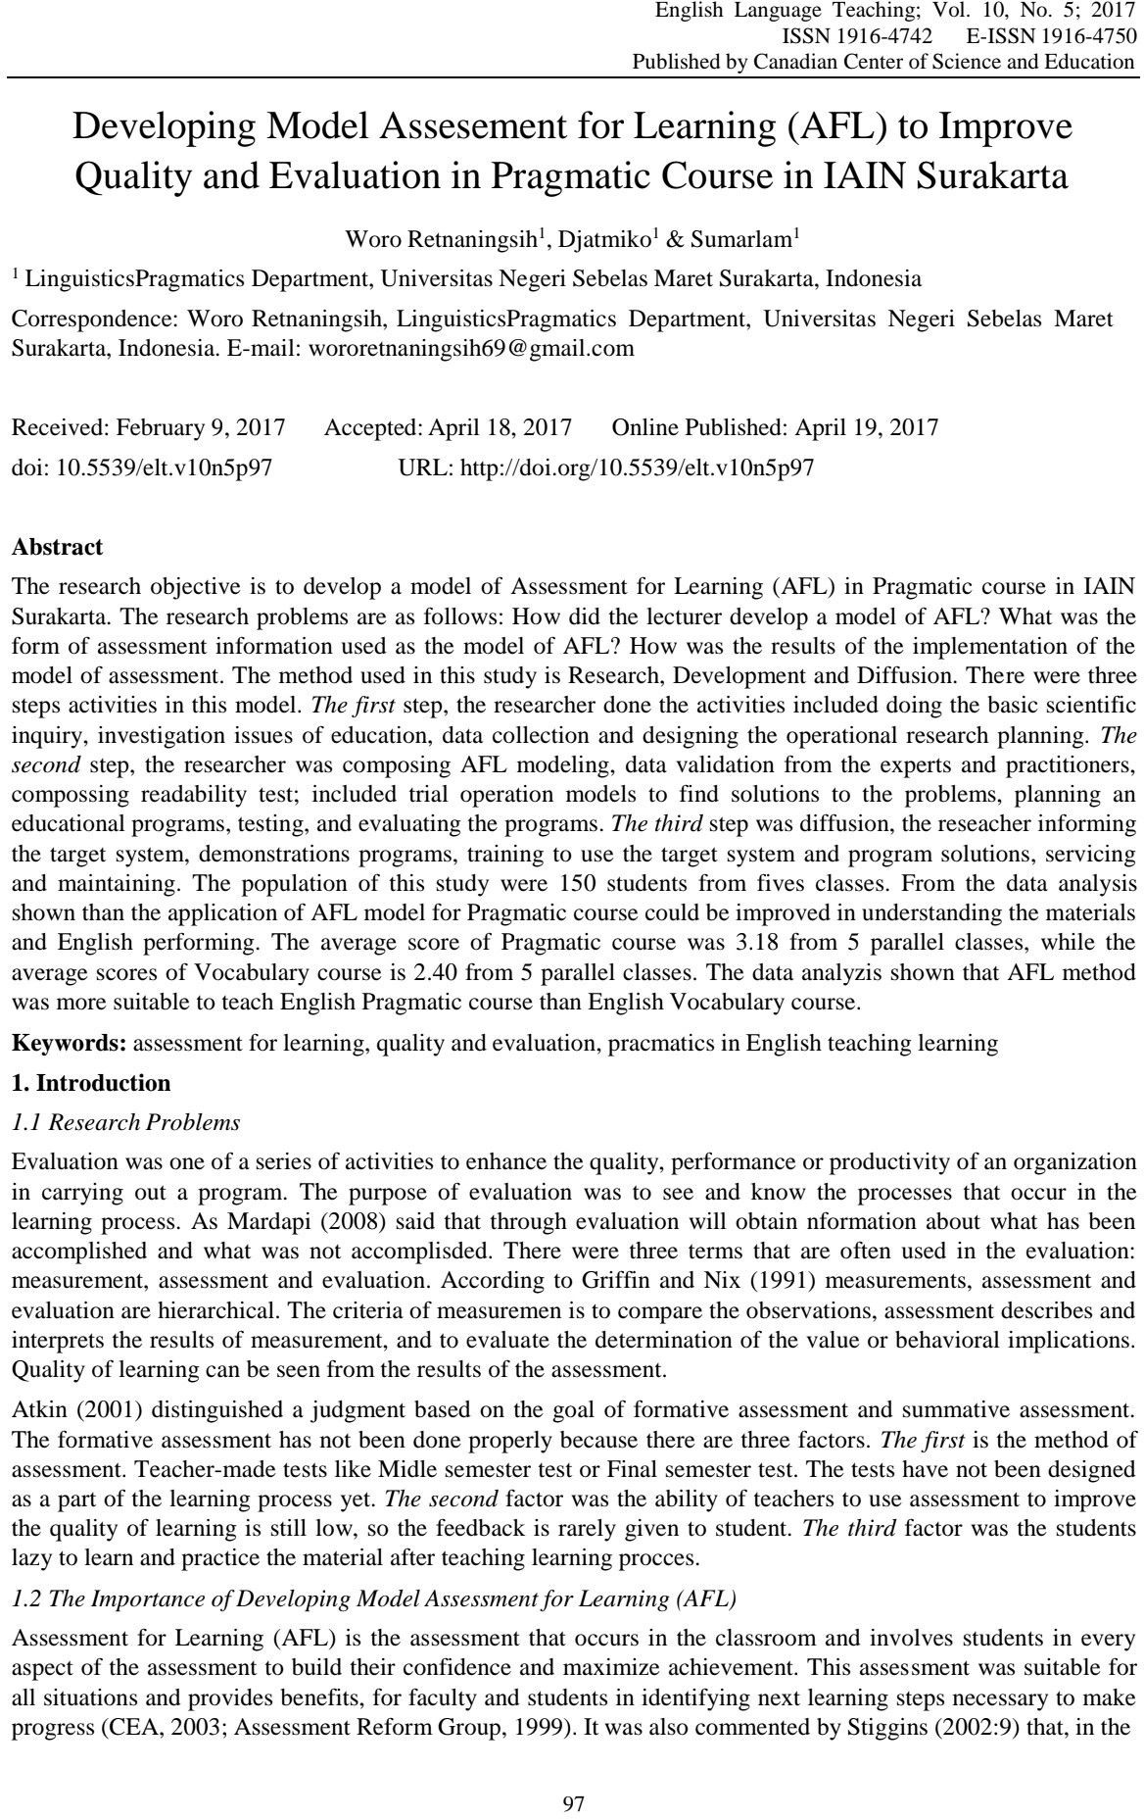

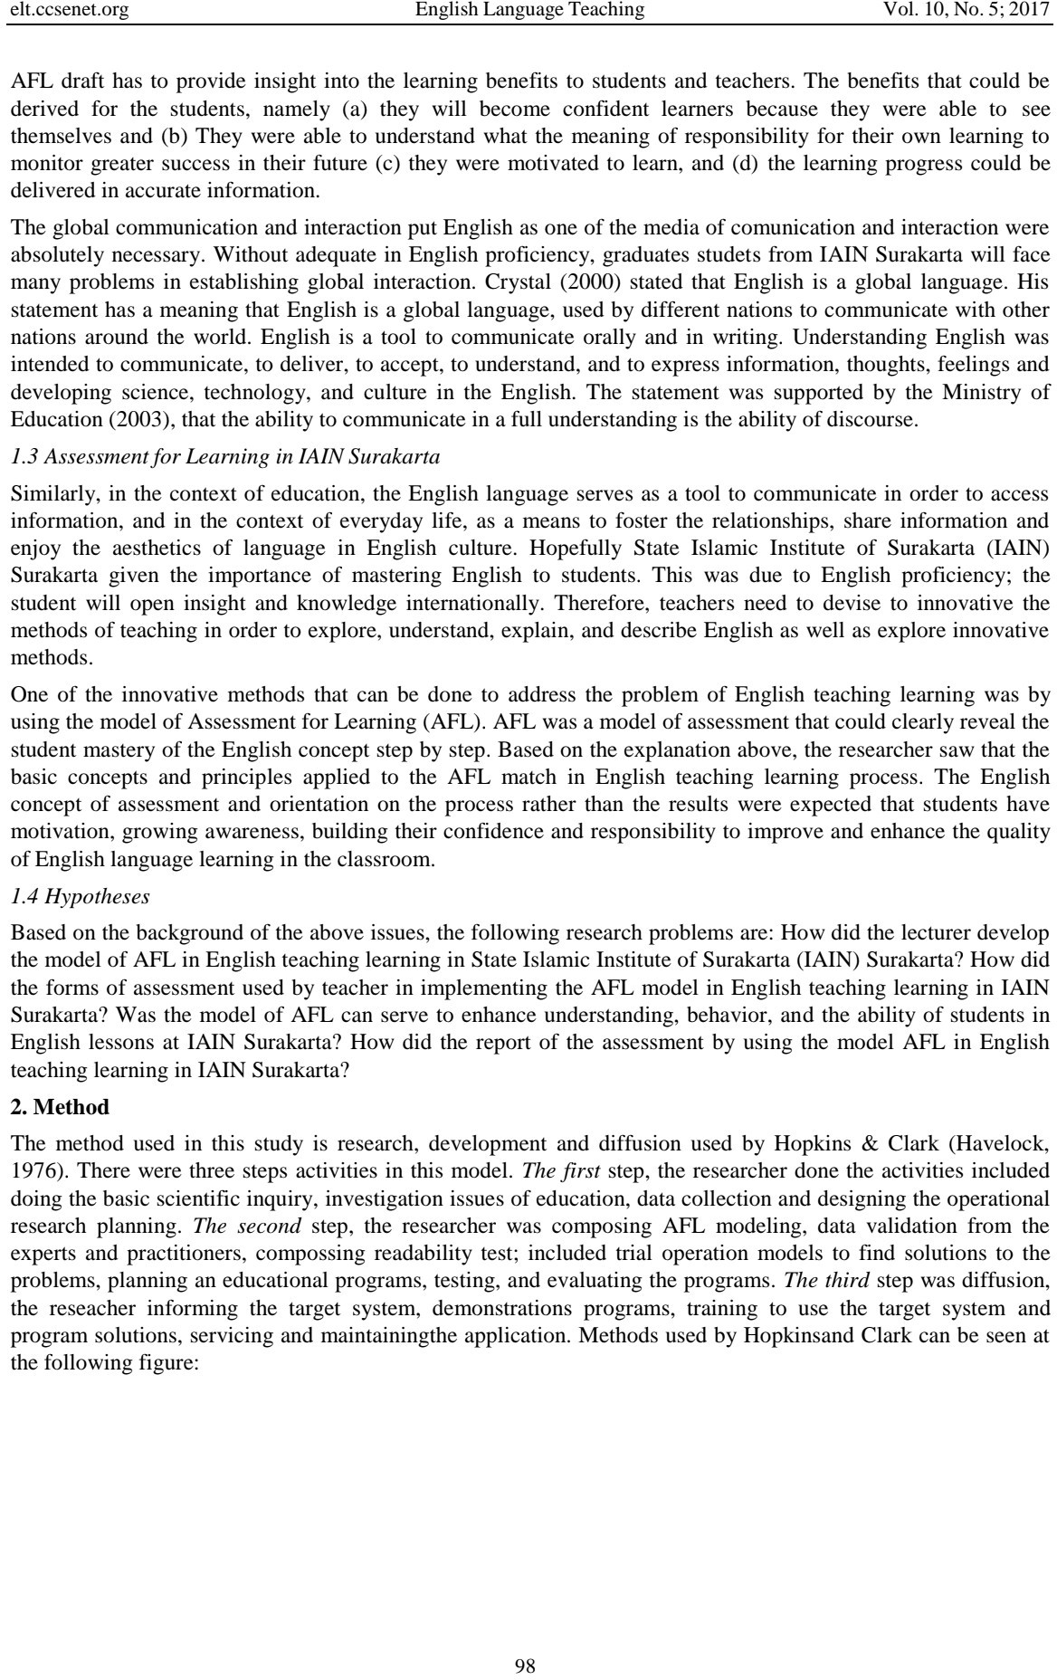

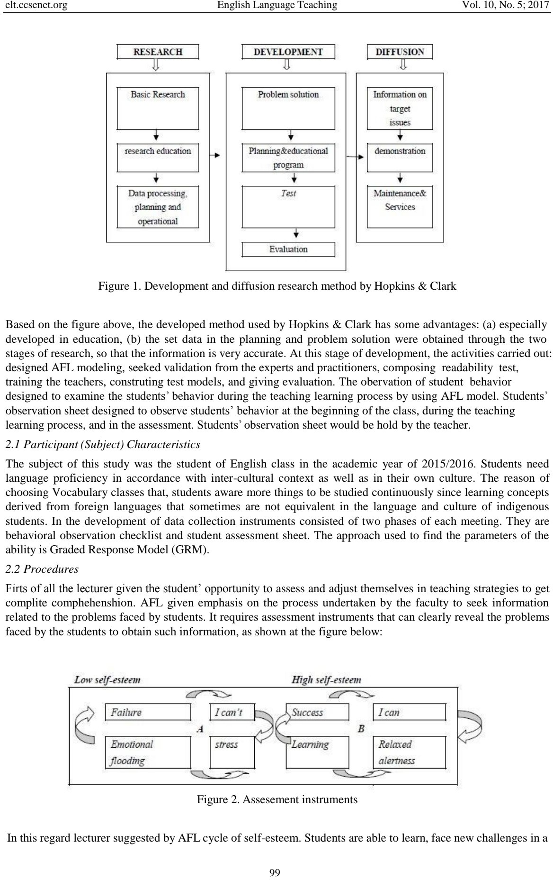

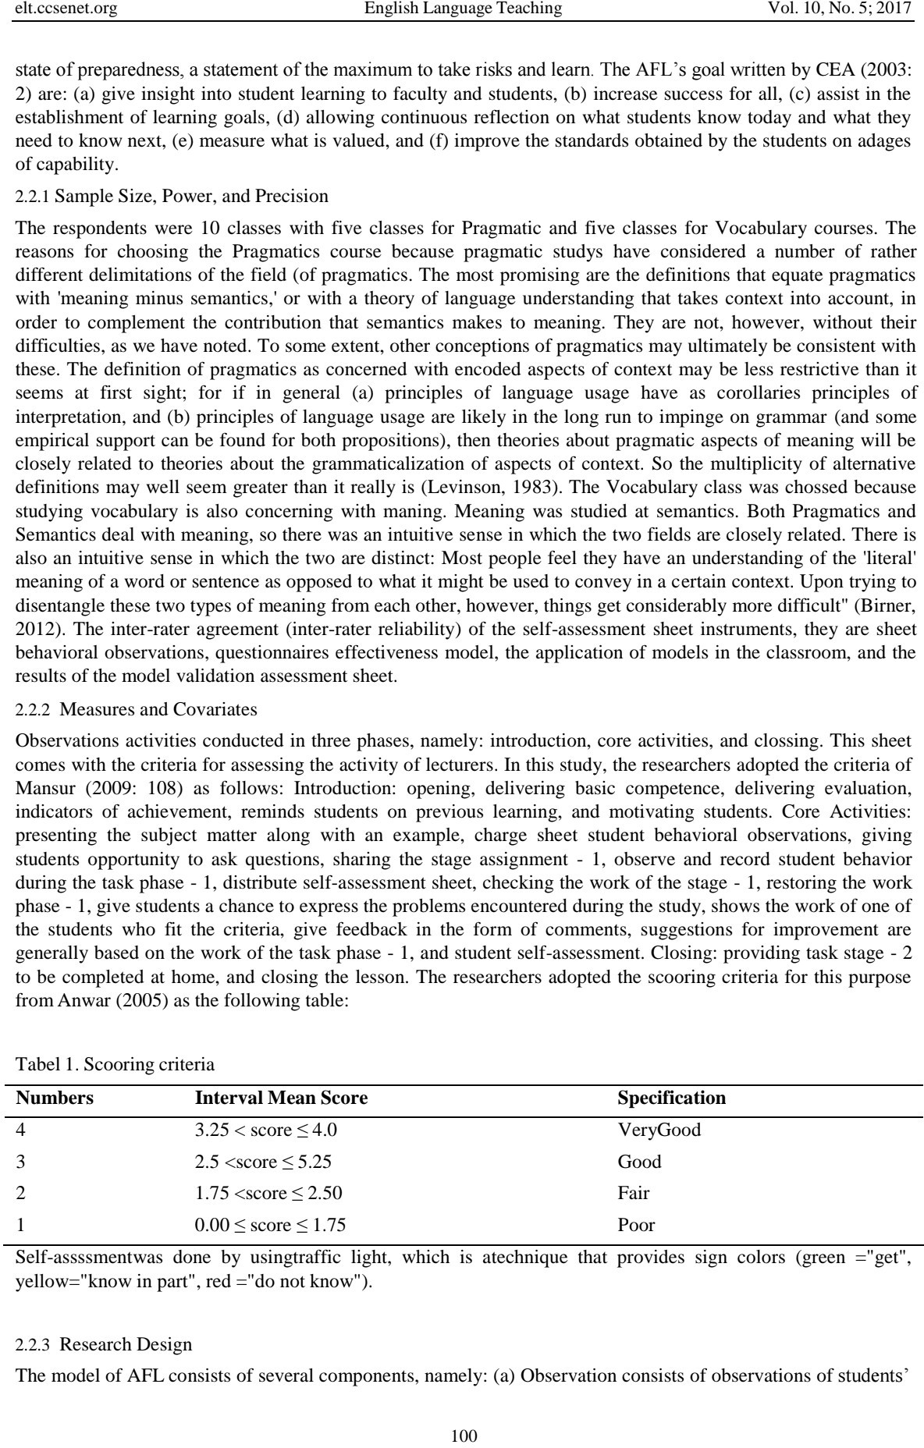

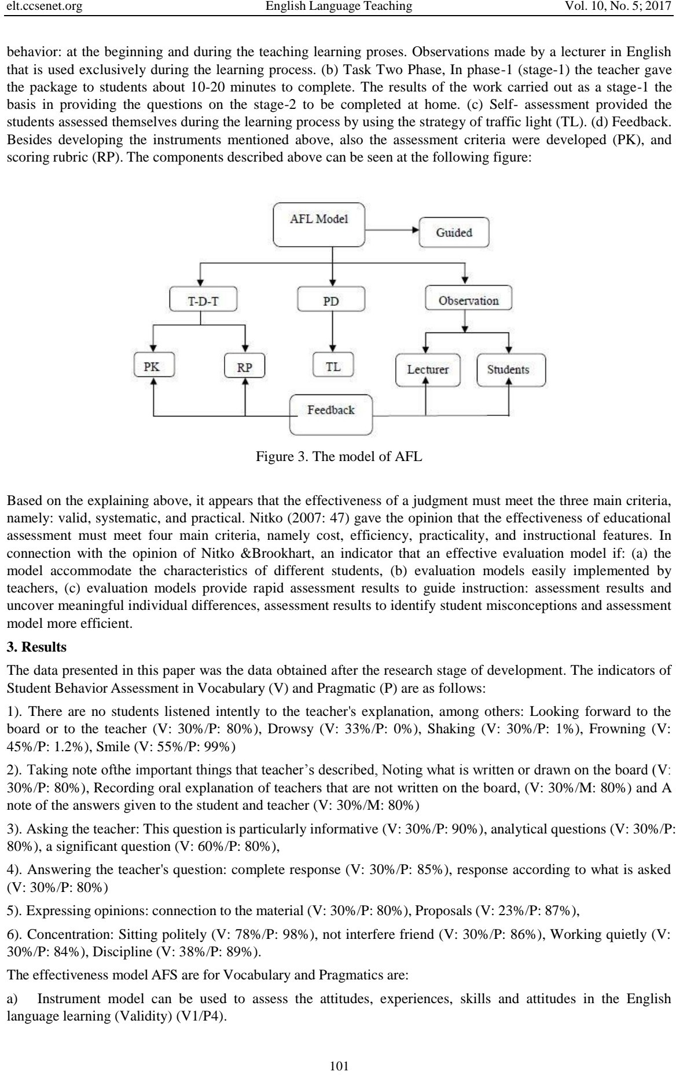

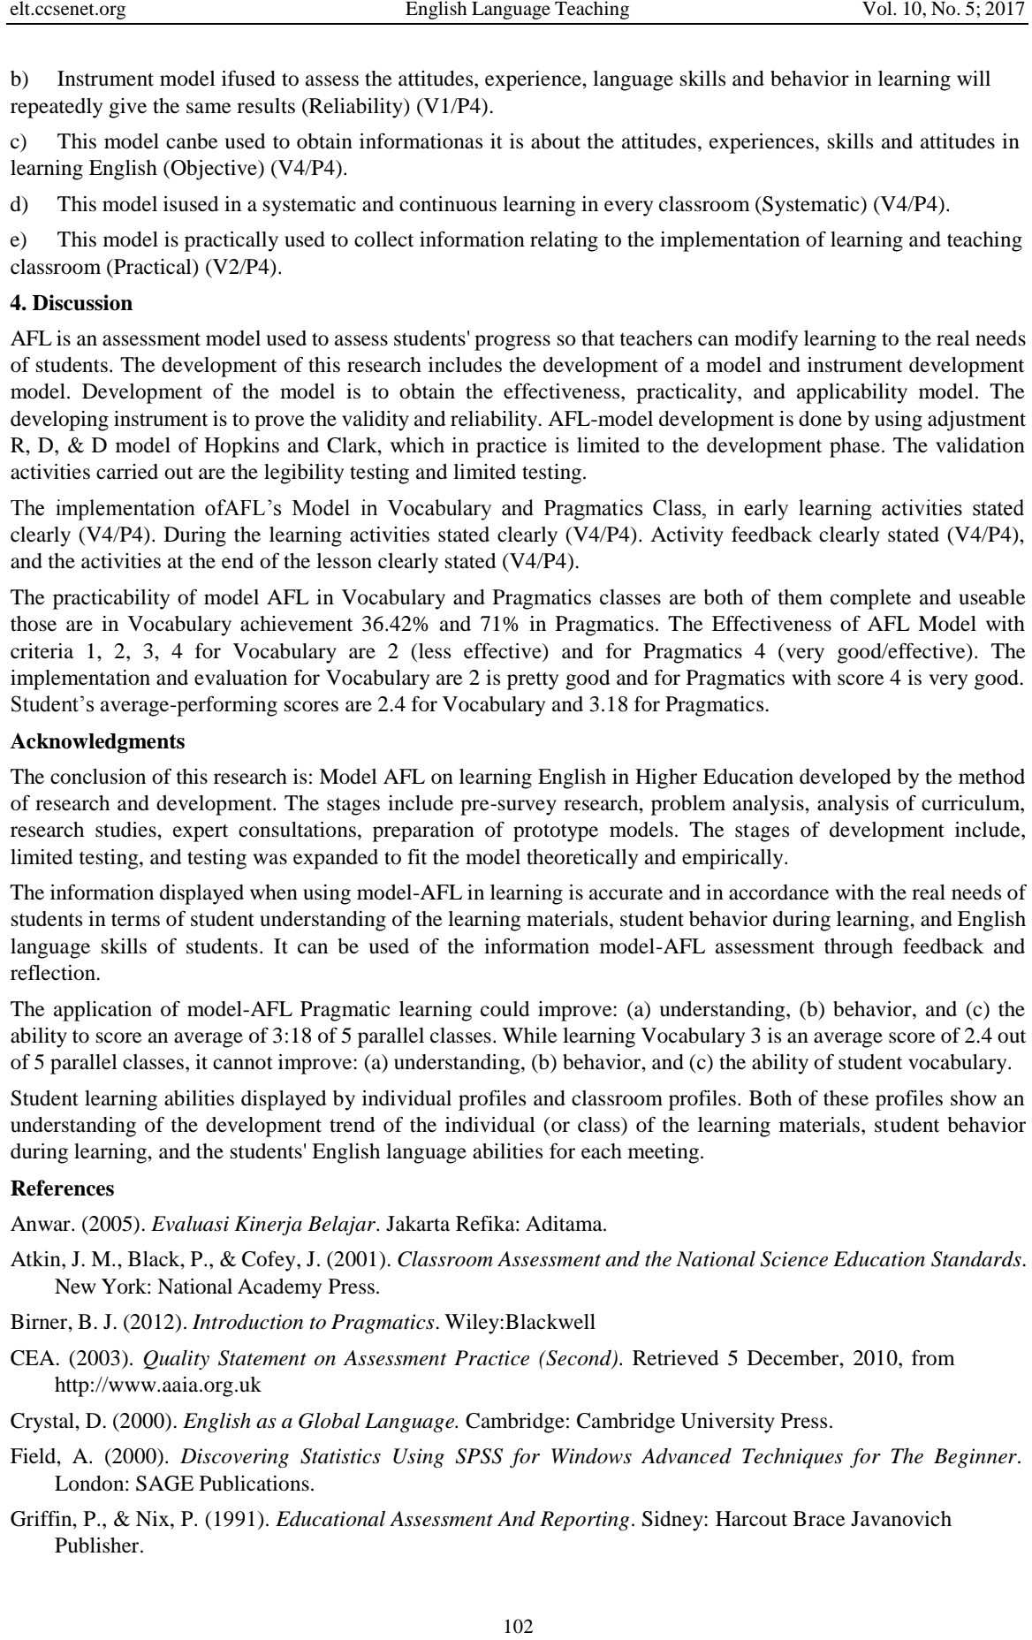

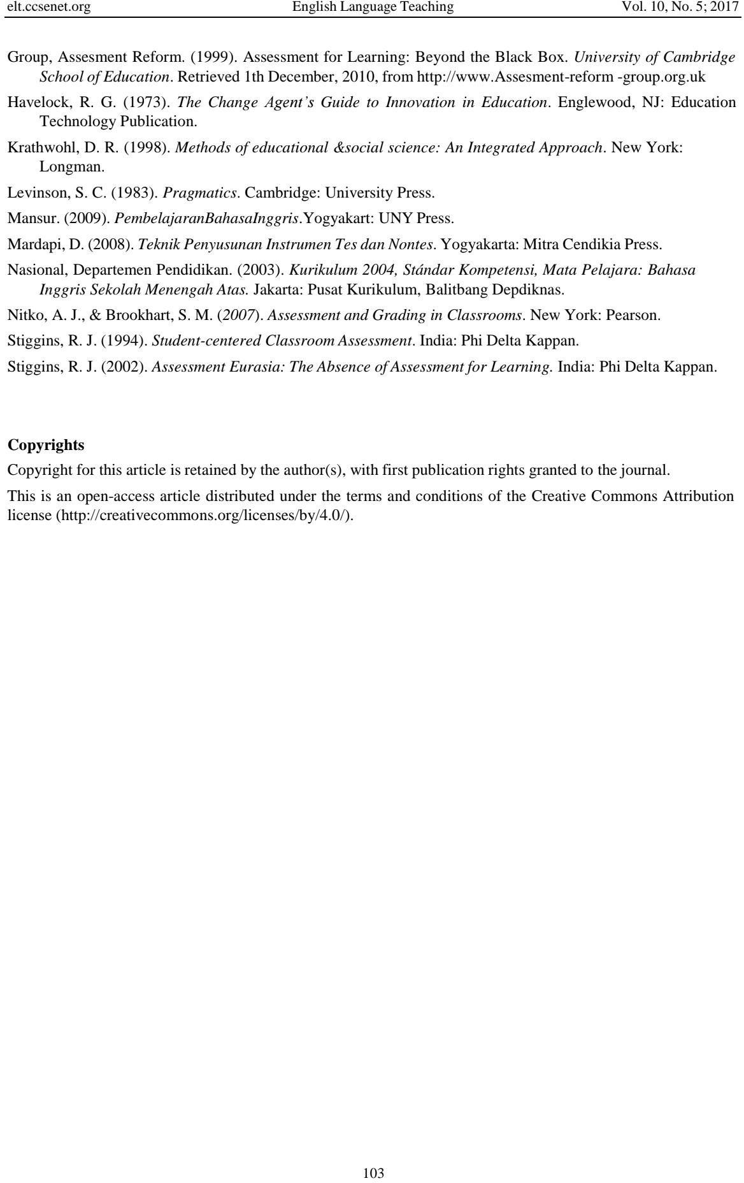

Developing Model Assesement For Learning (AFL) To Improve Quality and Evaluation In Pragmatic Course In IAIN Surakarta

ORIGINALITY REPORT
19%
SIMILARITY INDEX

9%
INTERNET SOURCES

4%
PUBLICATIONS

6%
STUDENT PAPERS

PRIMARY SOURCES

www.ijscl.net
1
5
Internet Source %

Submitted to Universitas Bina Darma
Student Paper %
2
4

e-journal.hamzanwadi.ac.id
Internet Source %
3
1

ejournal.radenintan.ac.id
Internet Source %
4
1

mjltm.org
Internet Source %
5
1

kuey.net
Internet Source %
6
1

jurnal.radenfatah.ac.id
Internet Source %
8
7
1
1

Nuha Abdullah AlSmari. "The Effect of Flipped %
Classroom Instruction on Developing Saudi
EFL Learners’ Comprehension of

Conversational Implicatures", International ournal of English Linguistics, 2020
Publication

Submitted to Eastern Illinois University
9
Student Paper

Submitted to Universitas Sebelas Maret
10
Student Paper

www.researchgate.net
11
Internet Source

files.eric.ed.gov
12
Internet Source

pdfs.semanticscholar.org
13
Internet Source

tohoku.repo.nii.ac.jp
14
Internet Source

Hamzeh Haghighi, Manoochehr Jafarigohar, Hooshang Khoshsima, Fereidoon Vahdany. "Impact of flipped classroom on EFL learners' appropriate use of refusal: achievement, participation, perception", Computer Assisted Language Learning, 2018
15
Publication

acikbilim.yok.gov.tr
16
Internet Source

rsuir-library.rsu.ac.th
17
Internet Source

1%
<1%
<1%
<1%
<1%
<1%
<1%

<1%
<1%

www.tandfonline.com
18
Internet Source

researchbank.swinburne.edu.au
19
Internet Source

www.unibulletin.com
20
Internet Source

Roberto Reinoso, Jaime Delgado-Iglesias, Itziar Fernández. "Effect of flipped teaching on the performance and perceptions of pre-service teachers on a biology course", Information and Learning Sciences, 2021
21
Publication

norr.numl.edu.pk
22
Internet Source

files.osf.io
23
Internet Source

www.gssrr.org
24
Internet Source

Submitted to Roehampton University
25
Student Paper

Submitted to University of Stirling
26
Student Paper

Laleh Khojasteh, Seyyed Ali Hosseini, Elham Nasiri. "The impact of mediated learning on the academic writing performance of medical
27
<1%
<1%
<1%
<1%

<1%
<1%
<1%
<1%
<1%
<1%

students in flipped and traditional classrooms: scaffolding techniques", Research and Practice in Technology Enhanced Learning, 2021
Publication

Submitted to Monash University
28
Student Paper

www.ejmste.com
29
Internet Source

"Optimal learning experience design in blended learning", Pontificia Universidad Catolica de Chile, 2018
30
Publication

Hsiu-Ting Hung. "Clickers in the flipped classroom: bring your own device (BYOD) to promote student learning", Interactive Learning Environments, 2016
31
Publication

asbcs.az.gov
32
Internet Source

jurnal.fkip.unila.ac.id
33
Internet Source

www.frontiersin.org
34
Internet Source

www.acarindex.com
35
Internet Source

<1%
<1%
<1%

<1%

<1%
<1%
<1%
<1%

"Posters", Basic & Clinical Pharmacology & Toxicology, 06/22/2010
36
Publication

Morena Lebens, Martin Graff, Peter Mayer. "The Affective Dimensions of Mathematical Difficulties in Schoolchildren", Education Research International, 2011
37
Publication

e-journal.stkipsiliwangi.ac.id
38
Internet Source

e-journal.undikma.ac.id
39
Internet Source

ejournals.umma.ac.id
40
Internet Source

mail.ijlter.org
41
Internet Source

services.kfu.edu.sa
42
Internet Source

www.j-humansciences.com
43
Internet Source

www.koreascience.or.kr
44
Internet Source

Abubakir Muhammad Mahmood, Behbood Mohammadzadeh. "The effectiveness of ICT- supported flipped learning in an EFL context:
45
<1%

<1%

<1%
<1%
<1%
<1%
<1%
<1%
<1%
<1%

A case of northern Iraq", Frontiers in Psychology, 2022
Publication

Fatma Gizem Karaoglan-Yilmaz, Ke Zhang, Ahmet Berk Ustun, Ramazan Yilmaz. "Transactional distance perceptions, student engagement, and course satisfaction in flipped learning: a correlational study", Interactive Learning Environments, 2022
46
Publication

dergipark.org.tr
47
Internet Source

e-journal.iain-palangkaraya.ac.id
48
Internet Source

link.springer.com
49
Internet Source

www.polodelconocimiento.com
50
Internet Source

www.tdx.cat
51
Internet Source

Mojdeh Shahnama, Behzad Ghonsooly, Majid Elahi Shirvan. "A meta-analysis of relative effectiveness of flipped learning in English as second/foreign language research", Educational Technology Research and Development, 2021
52
Publication

<1%

<1%
<1%
<1%
<1%
<1%
<1%

- Tianjiao Chen, Heng Luo, Peiyu Wang, Xin Yin, Jiaxin Yang. "The role of pre-class and in-class
behaviors in predicting learning performance and experience in flipped classrooms", Heliyon, 2023
Publication

- Wafa’ A Hazaymeh, Abdel Rahman M Altakhaineh. "The Effect of Flipped Classroom
Instruction on Developing Emirati EFL Learners’ Pragmatic Competence", International Journal of Learning, Teaching and Educational Research, 2019
Publication

- Xiangping Fan. "The development of EFL Learners’ willingness to communicate and self-efficacy: The role of flipped learning approach with the use of social media",
Frontiers in Psychology, 2022
Publication

jeltl.org
56
Internet Source

- Abudalslam Alfghe, Behbood Mohammadzadeh. "Realisation of the Speech Act of Request, Suggestion and Apology by
Libyan EFL Learners", SAGE Open, 2021
Publication
<1%

<1%

<1%

<1%
<1%

- Afroozeh Heidari, Hossein Heidari Tabrizi, Azizeh Chalak. "Using short stories vs. video
clips to improve upper intermediate EFL students’ sociopragmatic knowledge: Speech acts in focus", Cogent Arts & Humanities, 2020
Publication

- Chengyuan Jia, Khe Foon Hew, Du Jiahui, Li Liuyufeng. "Towards a fully online flipped
classroom model to support student learning outcomes and engagement: A 2-year design- based study", The Internet and Higher Education, 2022
Publication

- Hui-Chen Lin, Gwo-Jen Hwang, Shao-Chen Chang, Yaw-Don Hsu. "Facilitating critical
thinking in decision making-based professional training: An online interactive peer-review approach in a flipped learning context", Computers & Education, 2021
Publication

- Jingxuan Bi, Hossein Bigdeli, Siros Izadpanah. "The Effect of the flipped classroom on
reflective thinking, academic self-efficacy, and achievement motivation in language learners in intermediate level", Education and Information Technologies, 2023
Publication
<1%

<1%

<1%

<1%

- Mona M. Shalhoub. "chapter 3 Pragmatic Competence Development in Virtual
Environments in Light of the COVID-19 Pandemic in Higher Education in Palestine", IGI Global, 2023
Publication

research.gold.ac.uk
63
Internet Source
<1%

<1%

Exclude quotes Off Exclude bibliography Off
Exclude matches Off

